Software Requirements Specification

**Project Overview**

**TrainEase -** Train Ticket Booking System is a full-stack application designed to streamline train ticket booking processes. It allows users to register, search for trains, book tickets, and make secure online payments using Razorpay. The system leverages a microservices architecture for scalability and robustness..

**Team Members**

1. Aviral Singh
2. Ayush Srivastava
3. Harshit Kumar Goyal

**Technologies Used**

1. **Front-End**: ReactJS
2. **Back-End**: Spring Boot
3. **Database**: MySQL
4. **Authentication**: JWT (JSON Web Tokens)
5. **Service Discovery**: Eureka Server
6. **API Gateway**: Spring Cloud Gateway
7. **Logging**: Java Util Logging + Logback
8. **Testing**: JUnit, Mockito
9. **Build Tool**: Maven
10. **Version Control**: Git + Sonar Cube

**Microservices Architecture**

|  |  |  |  |
| --- | --- | --- | --- |
| **S No**. | **Service Name** | **Summary** | **Contribution** |
| 1 | Eureka Discovery Service | Eureka Server for discovering/registering all the services | Harshit Kumar Goyal |
| 2 | Gateway API Service | For accessing all the services through  Gateway Api port no | Aviral Singh |
| 3 | Registration Service | For registering user as a tenant, owner or an  admin | Ayush Srivastava |
| 4 | Login Service | For user authentication and authorization (with JWT auth filter) | Harshit Kumar Goyal |
| 5 | Train Management Service | Manages train schedules, locations, and seat availability. | Aviral Singh, Ayush Srivastava |
| 6 | Payment Service | Integrating payment gateway using  Stripe/Razorpay Api | Ayush Srivastava |
| 7 | Bookings Service | Handles train ticket bookings, cancellations, and status updates. | Harshit Kumar Goyal |

**Use Case Diagram**

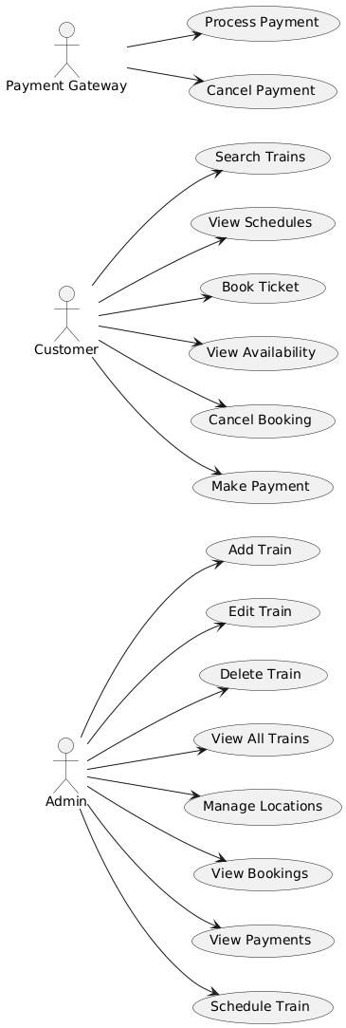

**Class Diagram**

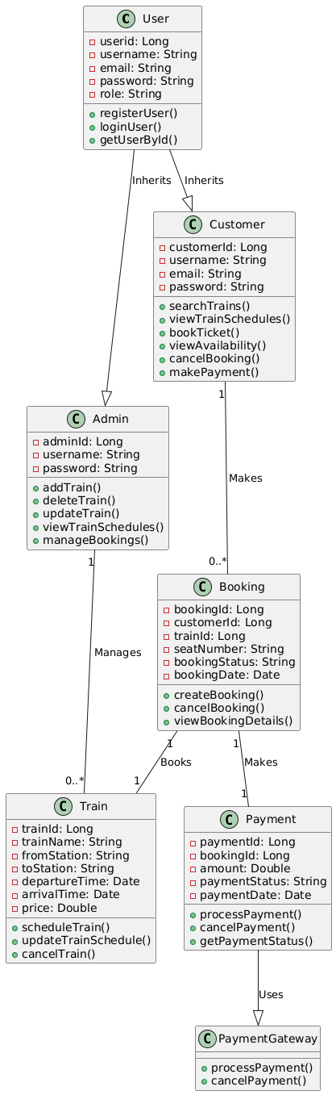

**Entity Relationship Diagram (ERD)**

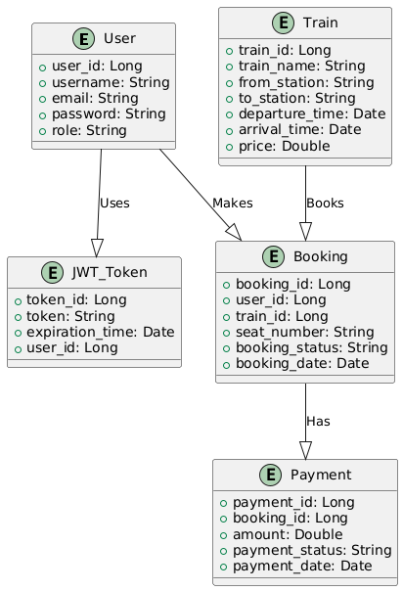

**Architectural Diagram**

